 LANs are networks that connect devices within a limited geographic area, such as a single building, a floor within a building, or a campus. The primary goal of a LAN is to facilitate fast and efficient communication between connected devices, which can include computers, printers, servers, and other networking devices.

**Packet Tracer: An Overview**

Packet Tracer is a simulation tool developed by Cisco that allows users to design, build, and configure network topologies in a virtual environment. It is widely used in networking courses and certifications to provide hands-on experience without the need for physical hardware. Packet Tracer supports various networking devices, including routers, switches, and end devices like computers.

**Creating a New Packet Tracer Project**

1. **Launch Packet Tracer:**

* Open the Packet Tracer application on your computer.

1. **Create a New Project:**

* Click on “File” and then select “New” to start a new Packet Tracer project.

**Designing the LAN Topology**

In this example, we’ll configure a simple LAN consisting of two computers connected to a switch. Follow these steps to design the topology:

1. **Add Devices:**

* From the left panel, drag and drop devices onto the workspace. For our basic LAN, use PCs as end devices and a switch to connect them.

1. **Connect Devices:**

* Use copper straight-through cables to connect the PCs to the switch. Click on the “Connections” button on the left panel, select the copper straight-through cable, and connect the devices by clicking on the desired interfaces on the switch and PCs.

1. **Arrange Devices:**

* Organize the devices on the workspace for a clear and logical layout. This step is optional but can enhance the visual representation of your network.

**Configuring IP Addresses on PCs**

For devices in a LAN to communicate, each device must have a unique IP address within the same subnet. Follow these steps to configure IP addresses on the PCs:

1. **Select a PC:**

* Click on one of the PCs to select it.

1. **Access Configuration Tab:**

* Click on the “Config” tab at the bottom of the screen to access the configuration options for the selected PC.

1. **Assign IP Address:**

* Manually assign an IP address to the PC. For example:
  + PC1: IP – 192.168.1.2
  + PC2: IP – 192.168.1.3
* Set the subnet mask, such as 255.255.255.0.

1. **Repeat for Other PCs:**

* Repeat the process for the other PCs, ensuring that each PC has a unique IP address within the same subnet.

**Configuring the Switch**

A switch is a crucial component in a LAN, responsible for forwarding data frames between connected devices. Follow these steps to configure the switch in Packet Tracer:

1. **Select the Switch:**

* Click on the switch to select it.

1. **Access Command Line Interface (CLI):**

* Click on the “CLI” tab at the bottom of the screen to access the Command Line Interface (CLI) of the switch.

1. **Enter Configuration Mode:**

Enter the following commands to configure the switch:

enable

configure terminal

interface range fa0/1 - 2 # Configuring all FastEthernet interfaces

switchport mode access # Setting interfaces as access ports

switchport access vlan 10 # Assigning VLAN 10 to the interfaces

exit

vlan 10

name LAN_VLAN # Naming the VLAN as LAN_VLAN

exit

write memory # Saving the configuration

This configuration sets up VLAN 10 on the switch and assigns the connected interfaces to this VLAN.

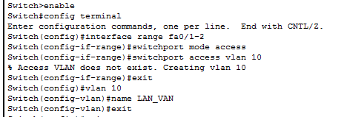



**Testing Connectivity**

Once the configuration is complete, it’s essential to test connectivity to ensure that devices within the LAN can communicate effectively. Follow these steps to test connectivity:

1. **Open Command Prompt:**

* Open the command prompt on one of the PCs.

1. **Ping Another PC:**

* Use the “ping” command to test connectivity to another PC. For example: ping 192.168.1.3 This command sends a series of packets to the specified IP address and checks for a response, verifying that the devices can communicate within the LAN.
* 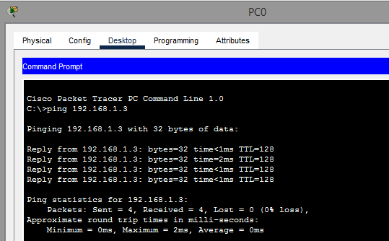

**Optional: Configuring Additional Features**

Depending on the specific requirements of your LAN, you may want to configure additional features, such as:

* **DHCP Server:** To automatically assign IP addresses to devices in the LAN.
* **File Sharing:** To enable sharing of files and resources between PCs.
* **Security Measures:** Implement security measures such as access control lists (ACLs) to control traffic.

**Saving the Packet Tracer Project**

After completing the configuration and testing, it’s crucial to save your Packet Tracer project to preserve your work. Follow these steps to save your project:

1. **Save the Project:**

* Click on “File” and then select “Save” to save your Packet Tracer project.